**Assignment-14**

**Hno:2053A52L16  
Lab 14: Web Design Application – AI-Assisted HTML/CSS/JS Generation**

**Task1:**

Create a personal portfolio website using HTML, CSS, and JavaScript. The website should have four sections — Home, About, Projects, and Contact. Generate the HTML structure, suggest responsive CSS styling using flexbox or grid, and add hover effects on project cards. The design should be clean, responsive, and visually appealing.

**Code:**

**1)Index.html**

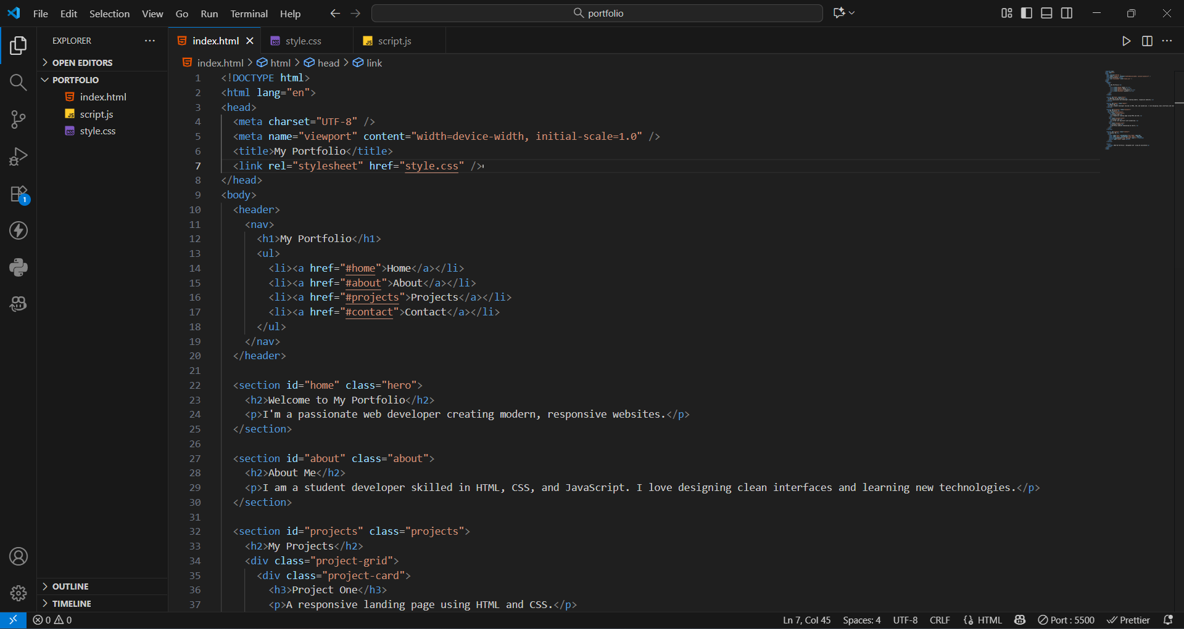

**2)style.css**

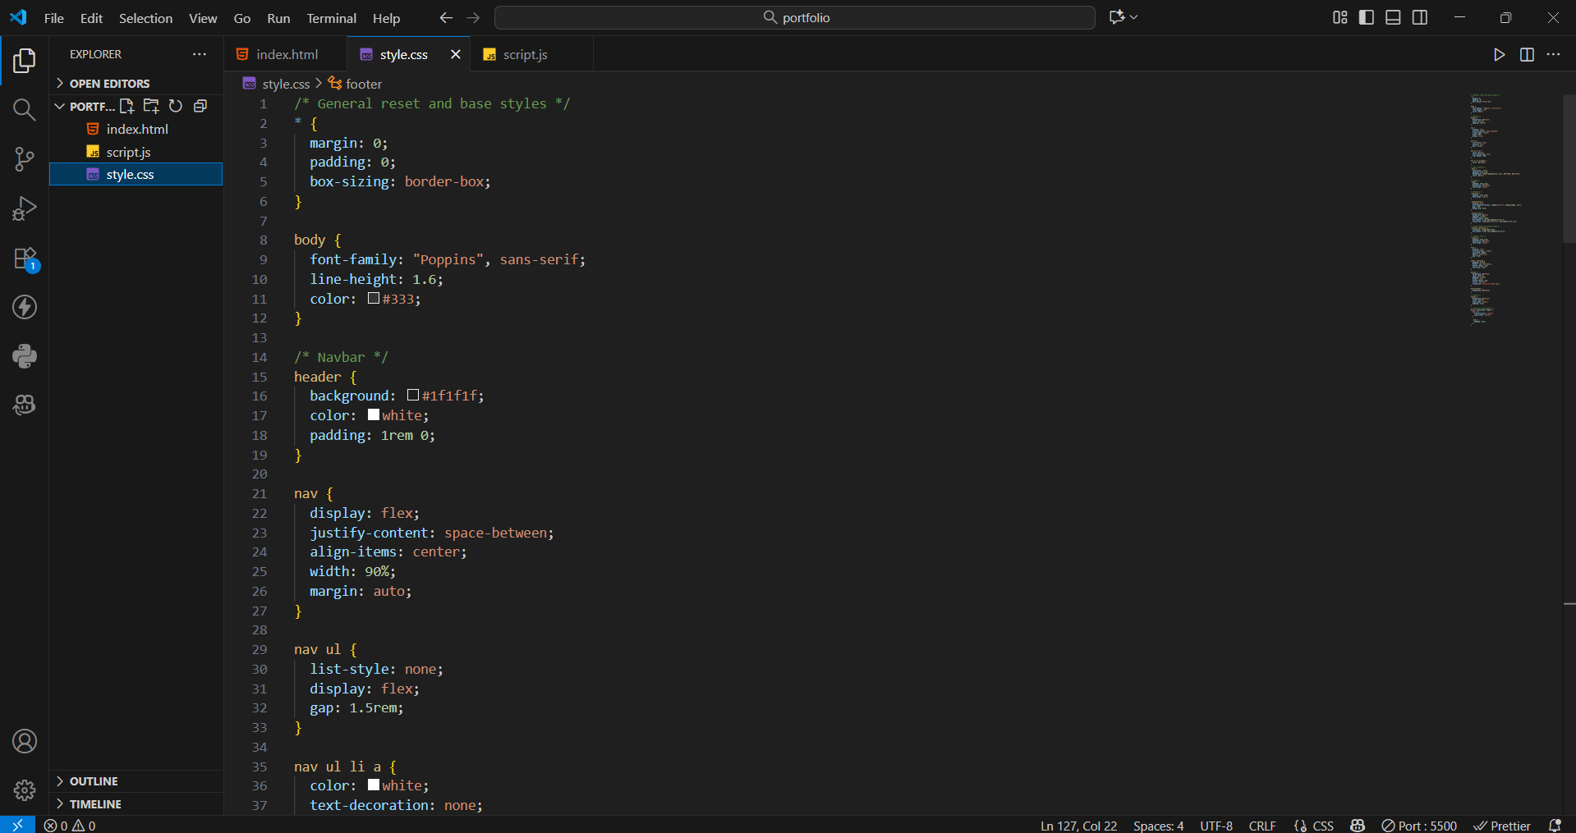

**3)script.js**

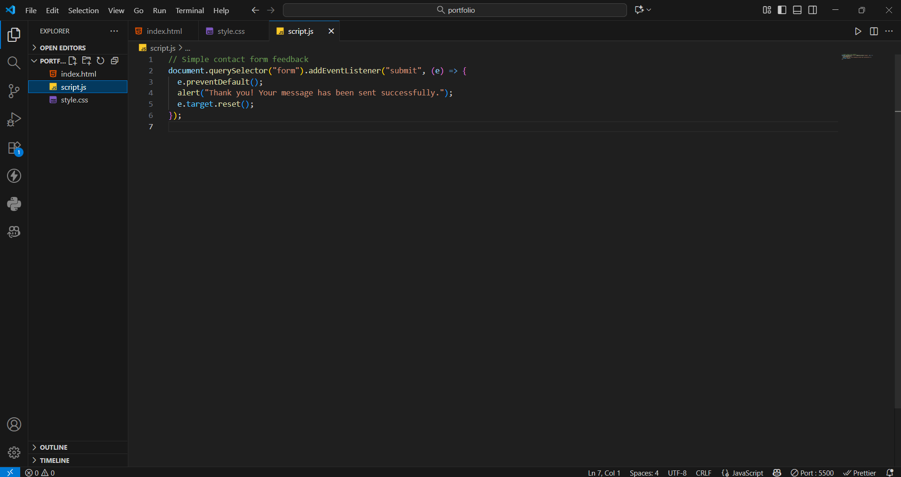

**Output:**

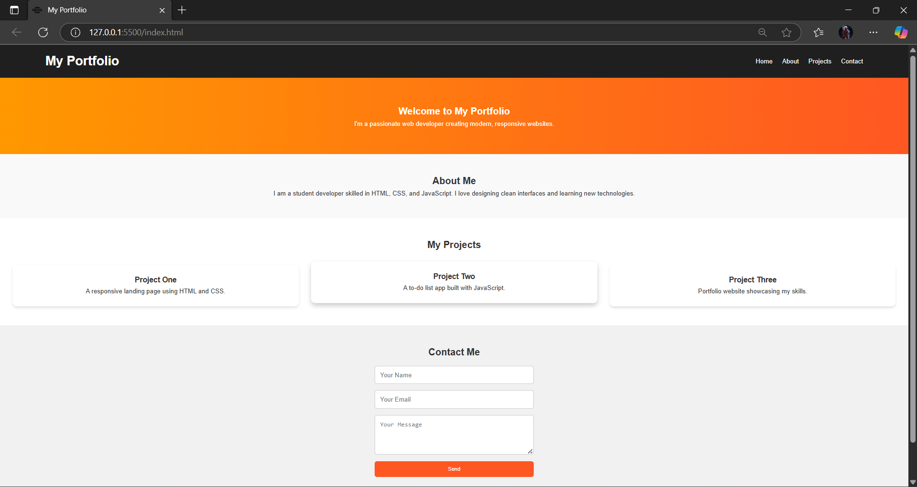

**Observation:**

Using GitHub Copilot, the portfolio website was quickly created with sections like Home, About, Projects, and Contact. The AI suggested responsive CSS using Flexbox/Grid and hover effects for interactivity, making the site visually appealing and easy to design efficiently.

**Task2:**

Create a restaurant landing page using HTML, CSS, and JavaScript with AI assistance. Include a navbar (Home, Menu, Gallery, Contact), a CSS-styled menu section, and a JS image slider.  
Then, build a tech fest registration form with fields like Name, Email, Phone, Department, and Event. Use Copilot to add styling and real-time input validation.

**Code:**

**1)restaurant.html**

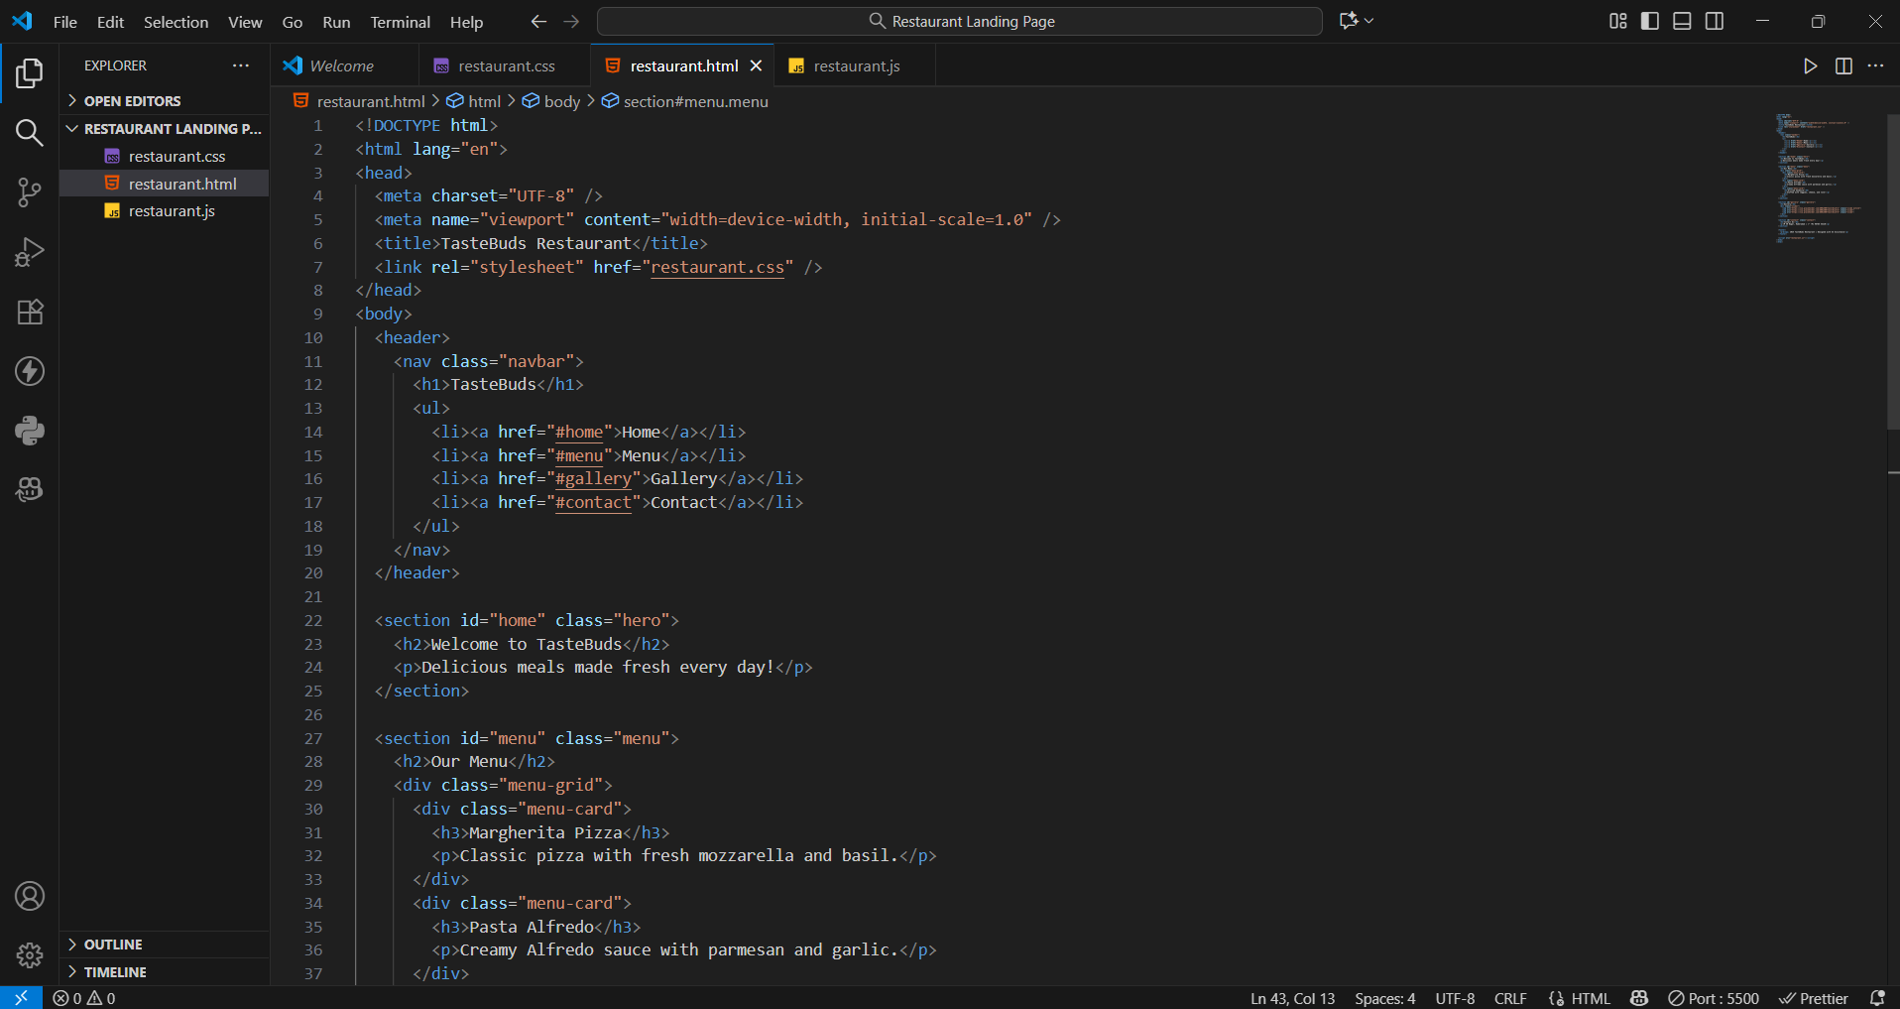

**2) restaurant.css**

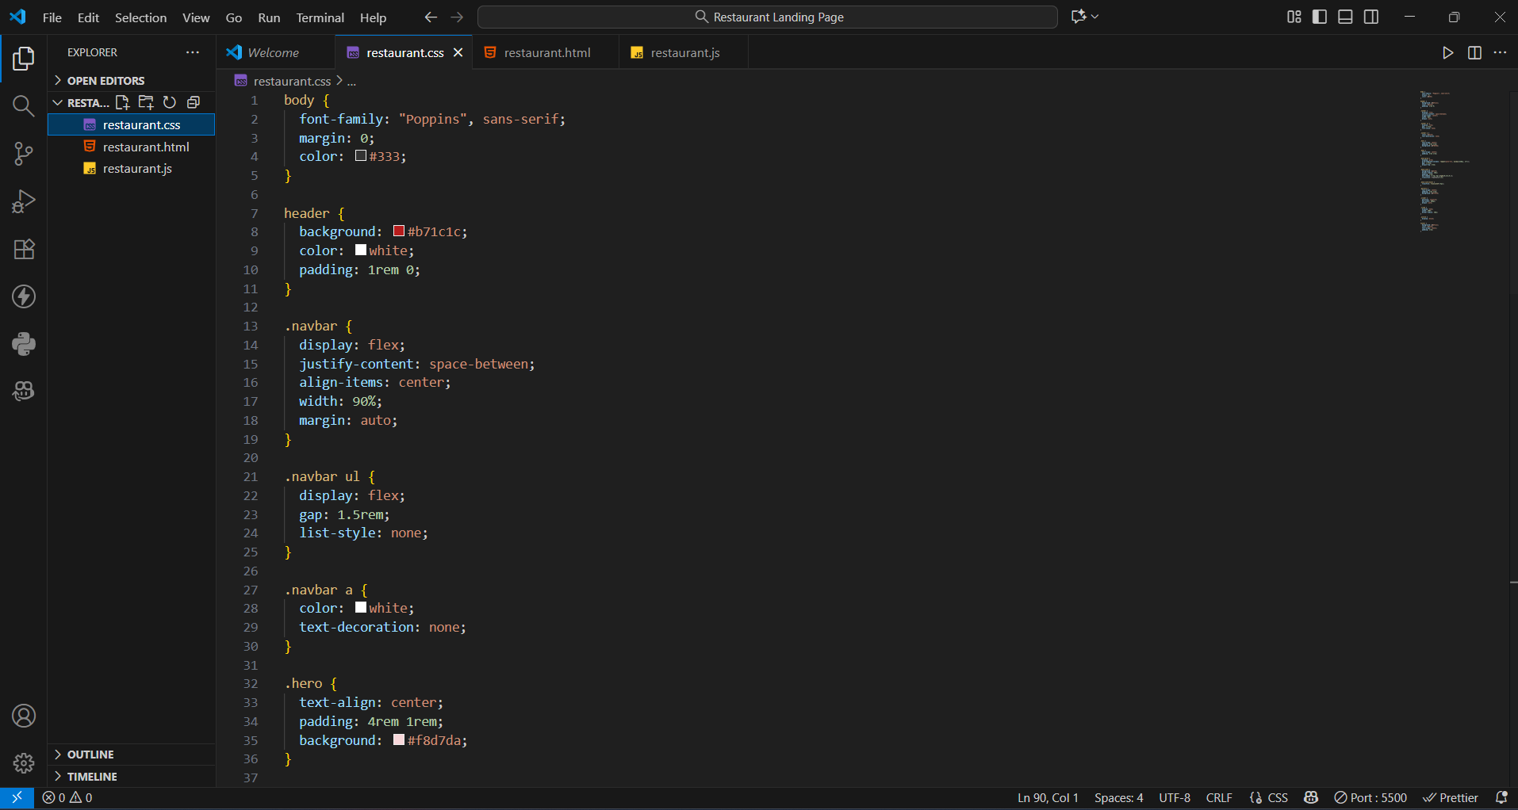

**3) restaurant.js**

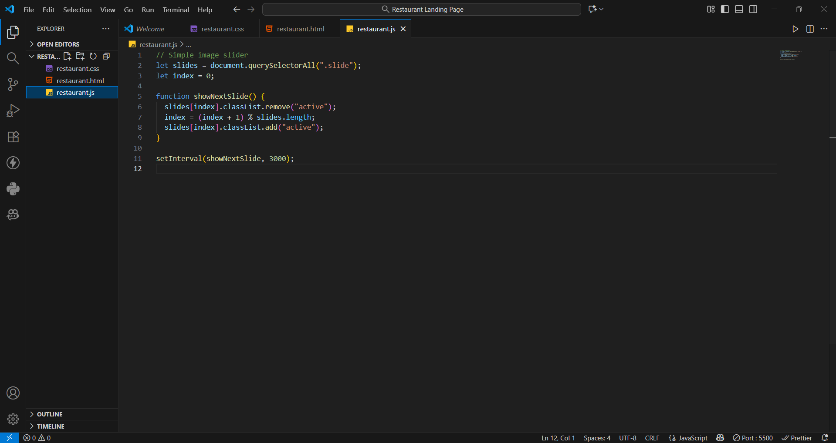

**Output:**

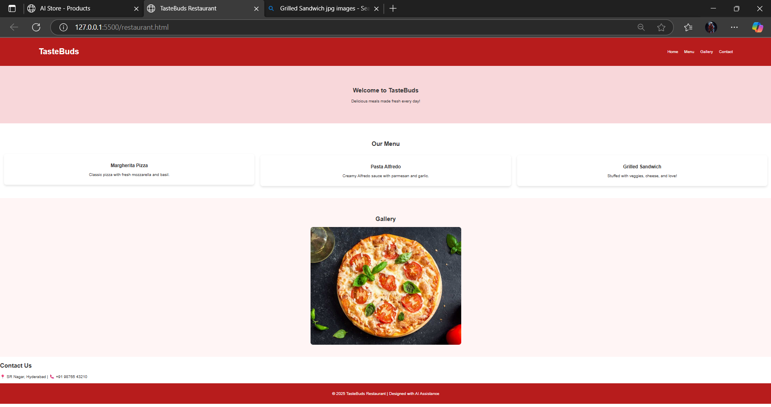

**Observation:**

Using AI assistance, the restaurant landing page was quickly generated with a navigation bar, menu cards styled in CSS, and an automated JavaScript image slider. The AI suggestions helped make the page responsive, interactive, and visually attractive.

**Task3:**

Then, create an **event registration form** for a university tech fest. The form should include fields for **Name, Email, Phone, Department, and Event Selection**. Use Copilot to help generate the **HTML form**, apply **attractive CSS styling**, and implement **real-time JavaScript validation** for email format and phone number length.

**Code:**

**1)event.html**

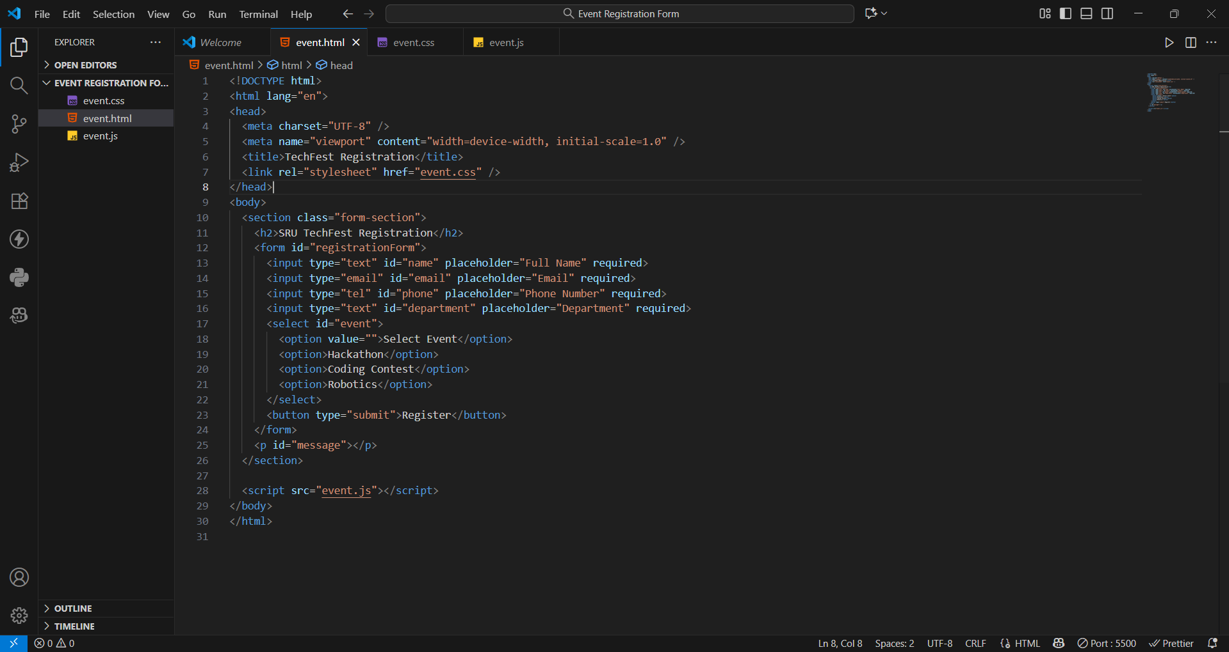

**2)event.css**

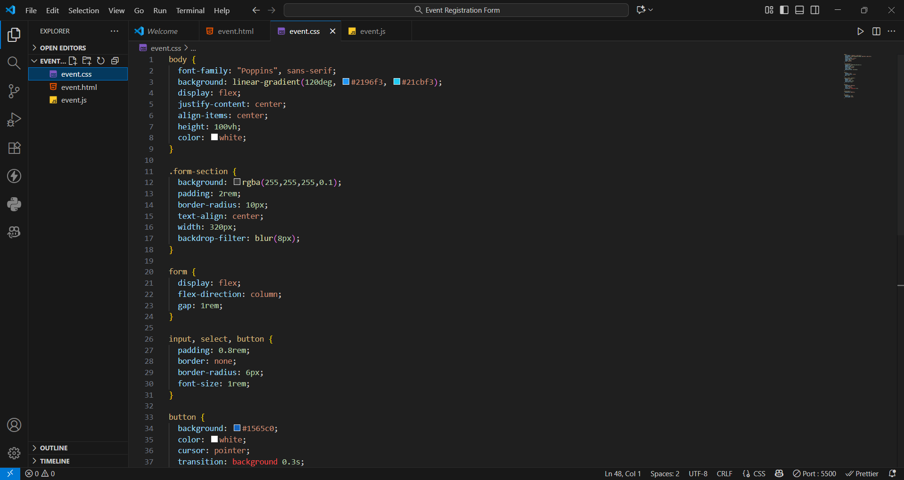

**3)event.js**

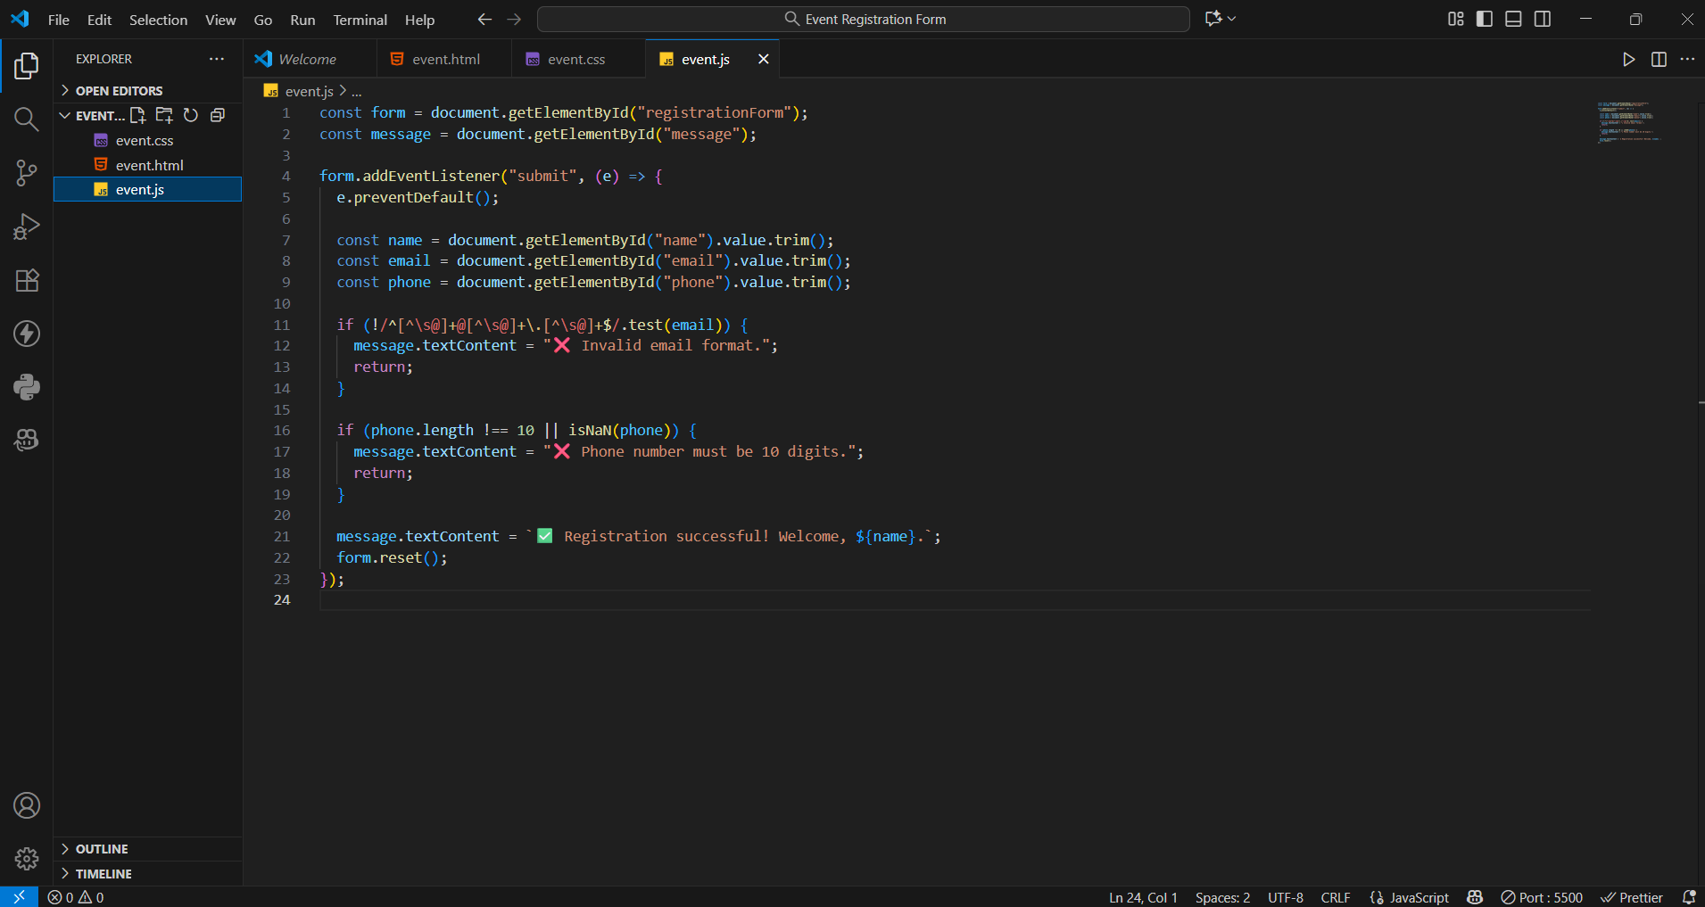

**Output:**

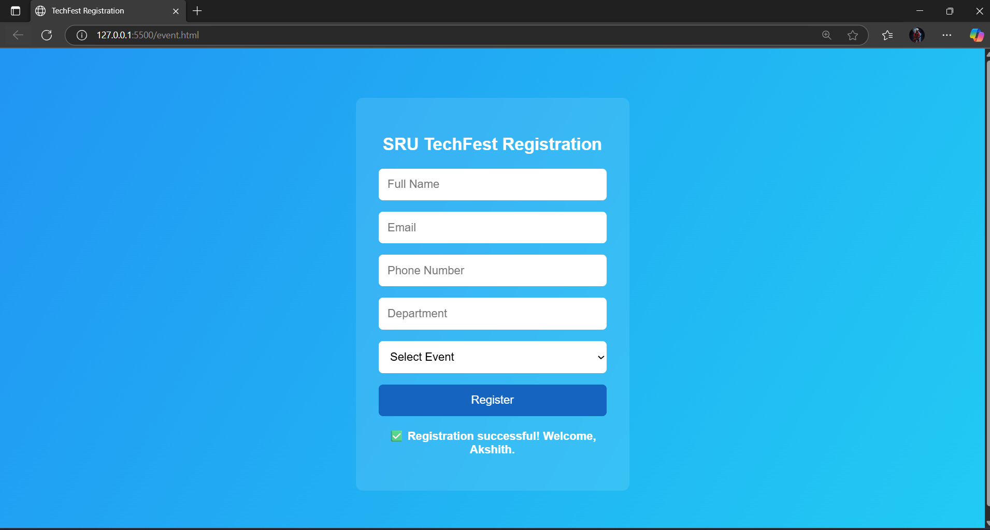

**Observation:**

With AI-generated suggestions, the registration form was designed with clean styling and real-time JavaScript validation. The AI assistance simplified input handling, improved accuracy, and made the overall development faster and more efficient.

**Task4:**

Create an e-commerce product page using HTML, CSS, and JavaScript with AI assistance. The page should display products in a responsive grid layout with names, prices, and “Add to Cart” buttons. Use Copilot to implement the JavaScript “Add to Cart” feature and modify it to include a cart counter at the top-right corner of the page

**Code:**

**1)ecommerce.html**

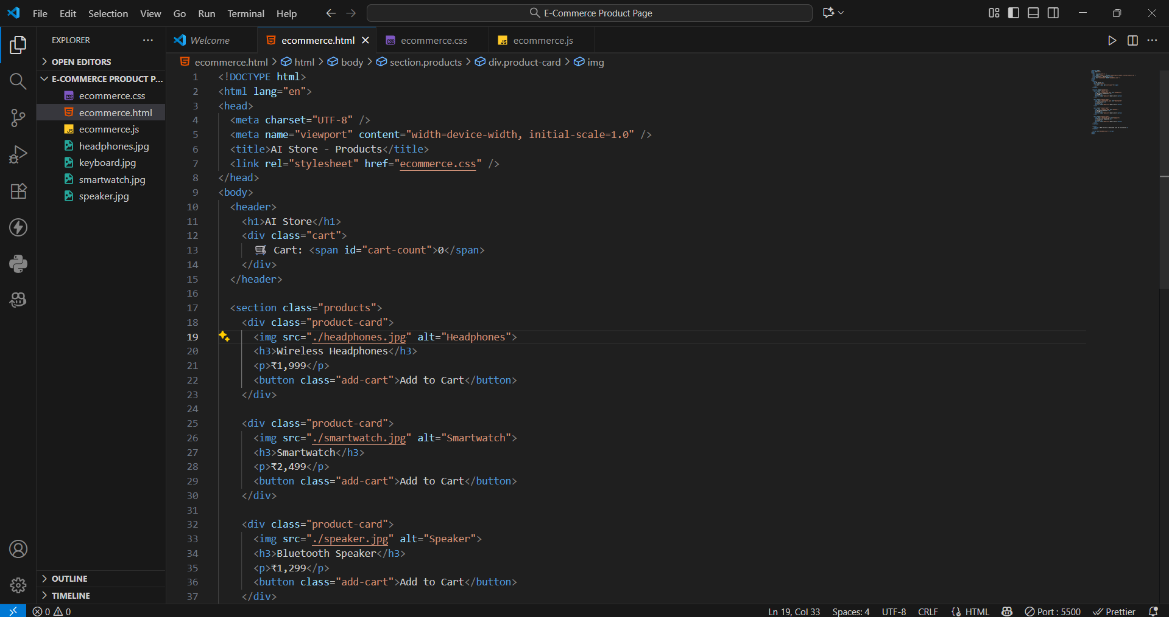

**2)ecommerce.css**

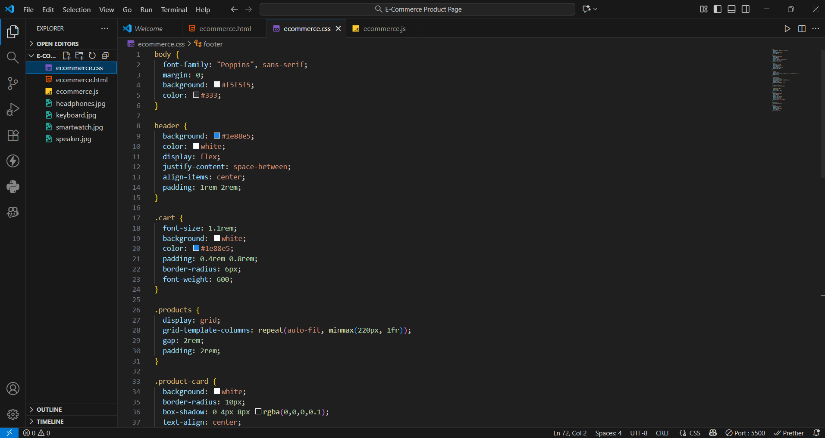

**3)ecommerce.js**

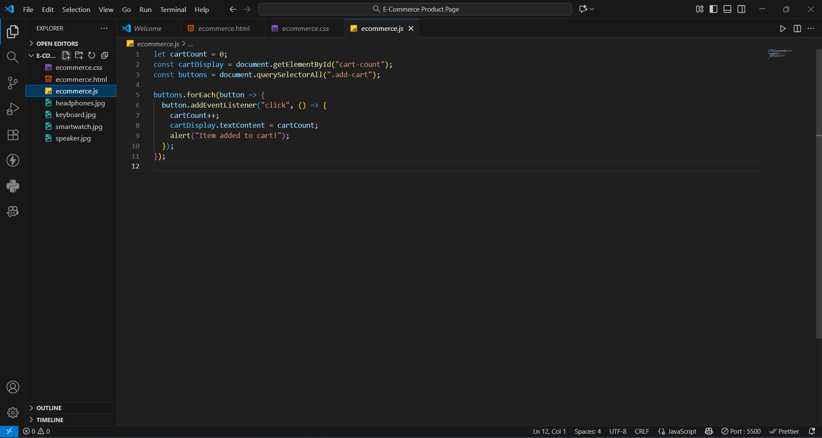

**Output:**

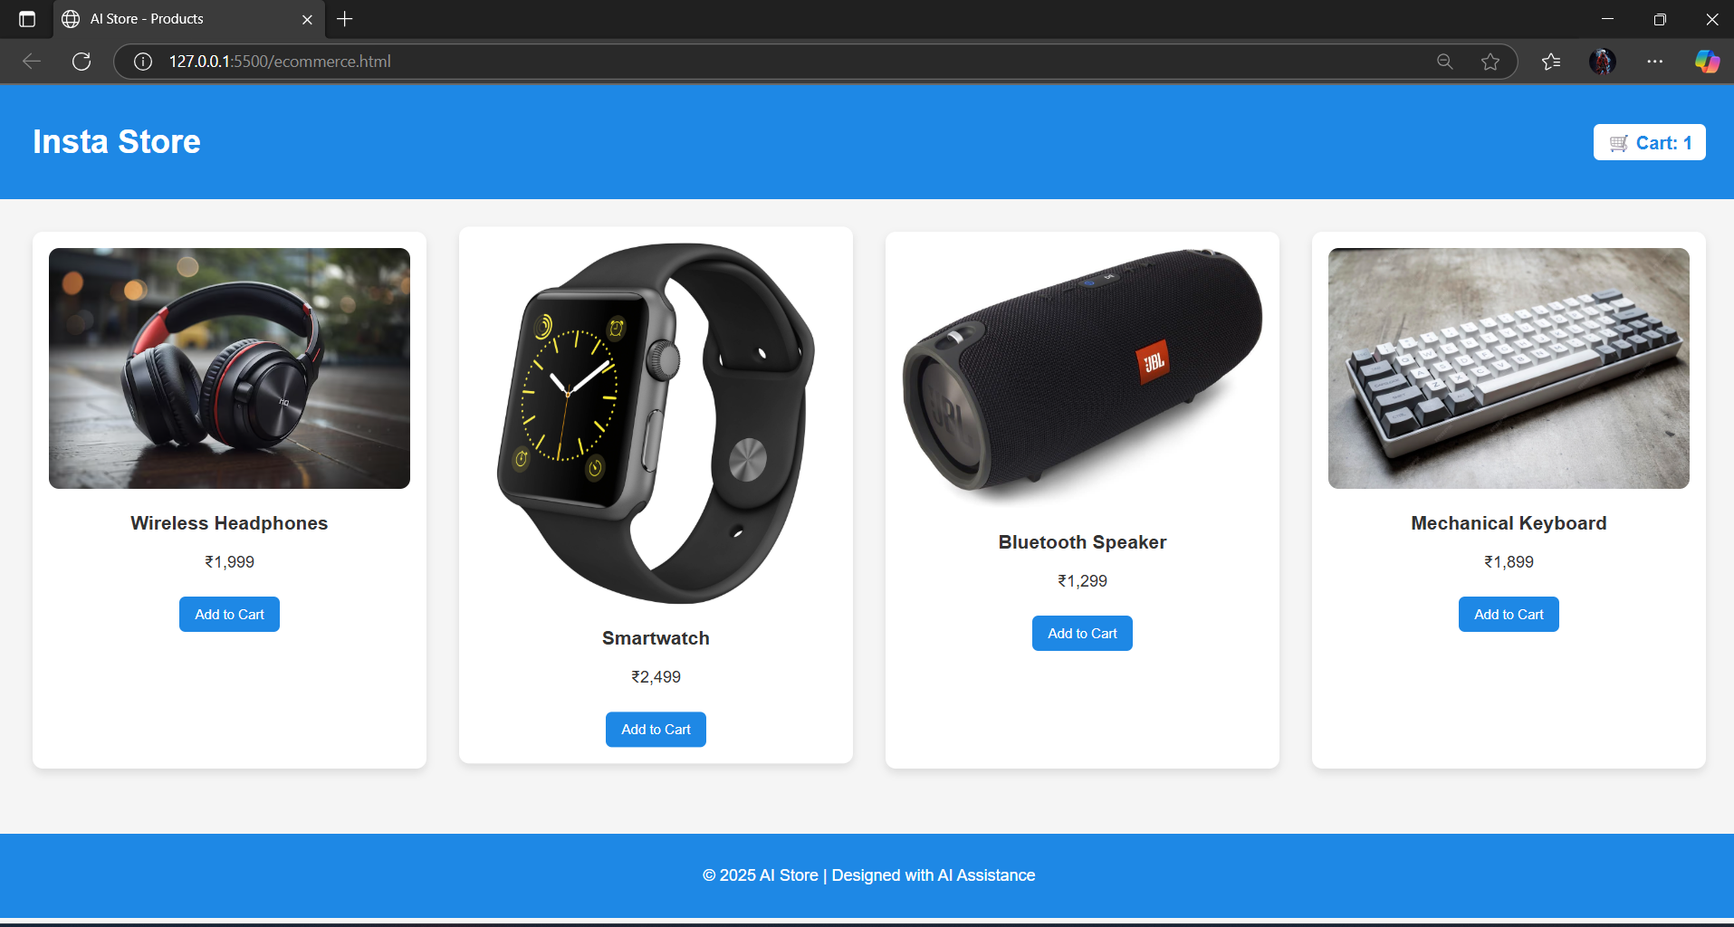

**Observation:**

Using GitHub Copilot, the e-commerce product page was created efficiently with a grid-based product layout and responsive design. The AI-assisted JavaScript “Add to Cart” feature worked smoothly, updating the cart counter dynamically. This task demonstrated how AI tools can simplify web development by providing instant, optimized code suggestions.